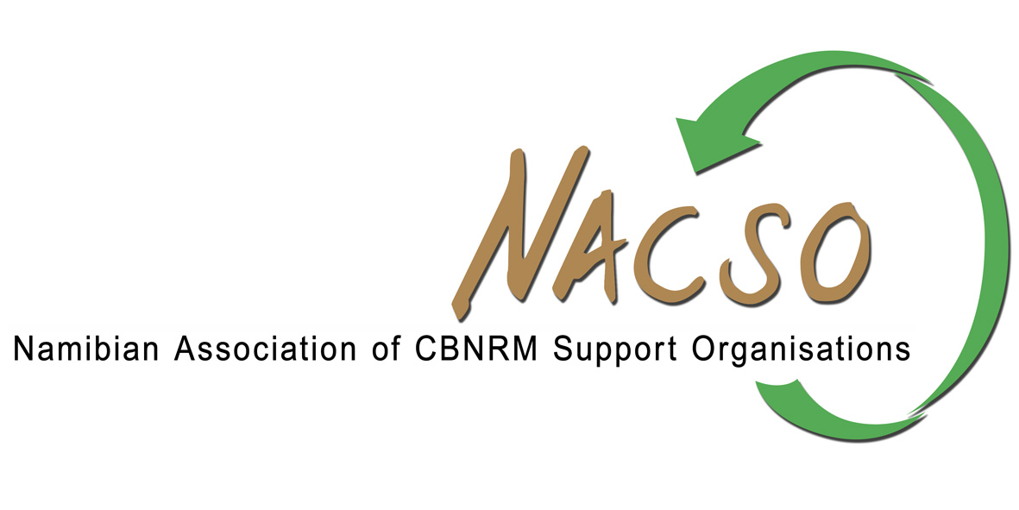

Press release

5 April 2016

NACSO, the Namibian Association of CBNRM Support organisations, notes and supports the position of the Governor of Zambezi Region, the Hon. Colonel L.A. Sampofu, taken in his letter to Members of the European Parliament, urging them to investigate how hunting has secured conservation in the region, and not threatened it.
NACSO is fully committed to supporting Namibian communal conservancies and Regional Conservancy Associations in their opposition to any ban on the importation of hunting trophies to the European Union.
To date, the Kunene Regional Community Conservancy Association, representing 29 conservancies, 15 Zambezi Region conservancies, and the Kyaramacan Association representing residents in Bwabwata National Park have all written letters to MEPs, and conservancies in Kunene South and Erongo are currently writing letters in opposition to any proposed ban.
As stated in a previous press release, NACSO fully supports the position of the Namibian government in its opposition to a ban on the importation of hunting trophies to the EU, on the grounds that this would damage the Namibian economy and conservation efforts.
NACSO is actively engaging with EU ambassadors in Namibia to apprise them of the risks of any ban.

Maxi Louis
Director
NACSO

