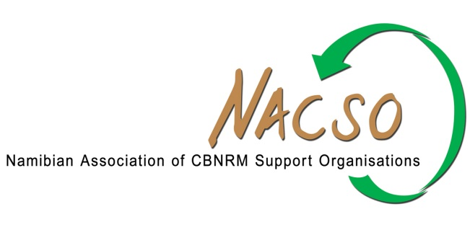

NACSO Media Statement: Poaching of Rhino in the Omusati Region
1st of July 2014
The Namibian Association of CBNRM Support Organisations, NACSO, is gravely concerned over the recent rhino poaching incident in the Uukwaluudhi Conservancy. This is the latest case in a commercial poaching upsurge in Namibia. NACSO is fully aware of the seriousness of the poaching threat facing our country and is working closely with the Ministry of Environment and Tourism (MET) to provide any possible support that can assist in the fight against wildlife crime.
The recent case demonstrates that wildlife crime syndicates are now fully active in Namibia. Such poaching in remote areas cannot take place without some local knowledge. Communal conservancies are in a position to work actively with their members to minimise such involvement and ensure reporting of suspicious activities. NACSO member organisations are supporting conservancies in this regard.
Poaching is stealing from the community. The loss of our valuable wildlife directly affects the livelihoods of rural Namibians, the tourism industry and our economy as a whole. All Namibian citizens can actively contribute to reducing wildlife crime by reporting any suspicious activities.
NACSO continues to support the work of community game guards through a number of initiatives that further improve monitoring of valuable species and help to combat poaching. In this, as in all of its activities, the NACSO Secretariat and NACSO members are working closely with the MET.
A number of people have in recent months been arrested for crimes related to poaching and trafficking of animal parts. In many cases, the arrests of the suspects have been made possible through information and support from local communities. Namibia’s judiciary can now give clear signals that such crimes are considered completely unacceptable in this country and will be swiftly and harshly dealt with.
The media also has a direct responsibility in helping to protect our national heritage and valuable wildlife through responsible reporting. While the public should always be informed about incidents of national concern, divulging details of a case as it is being uncovered can compromise investigations and may reduce the effectiveness of law enforcement.
The active collaboration between the MET, the Protected Resources Unit of the Namibian Police, NACSO and its members (which include Save the Rhino Trust, the Legal Assistance Centre and IRDNC), communal conservancies and local communities can create a force that can stop the poaching of our rhinos and elephants.
Report any suspicious behaviour by sms to the Rhino and Elephant Security Hotline: 55555

