PRESS RELEASE

Sorris-Sorris – A Conservancy on the Move!

On Saturday, Sorris-Sorris Conservancy hosted a gala dinner – the first of its kind for conservancies in Namibia. Many conservancies struggle to cover their basic operating costs, yet Sorris-Sorris is the first to try a new way of raising funds. The objectives of the gala dinner were: to assist the conservancy with funds for human-wildlife conflict; to put money towards building staff accommodation; to help cover the costs for the upcoming Conservancy Cup to be held by the conservancy. The proceeds from this soccer tournament, held from the 1st to the 5th of October 2014, will also add to the conservancy’s fund-raising efforts.

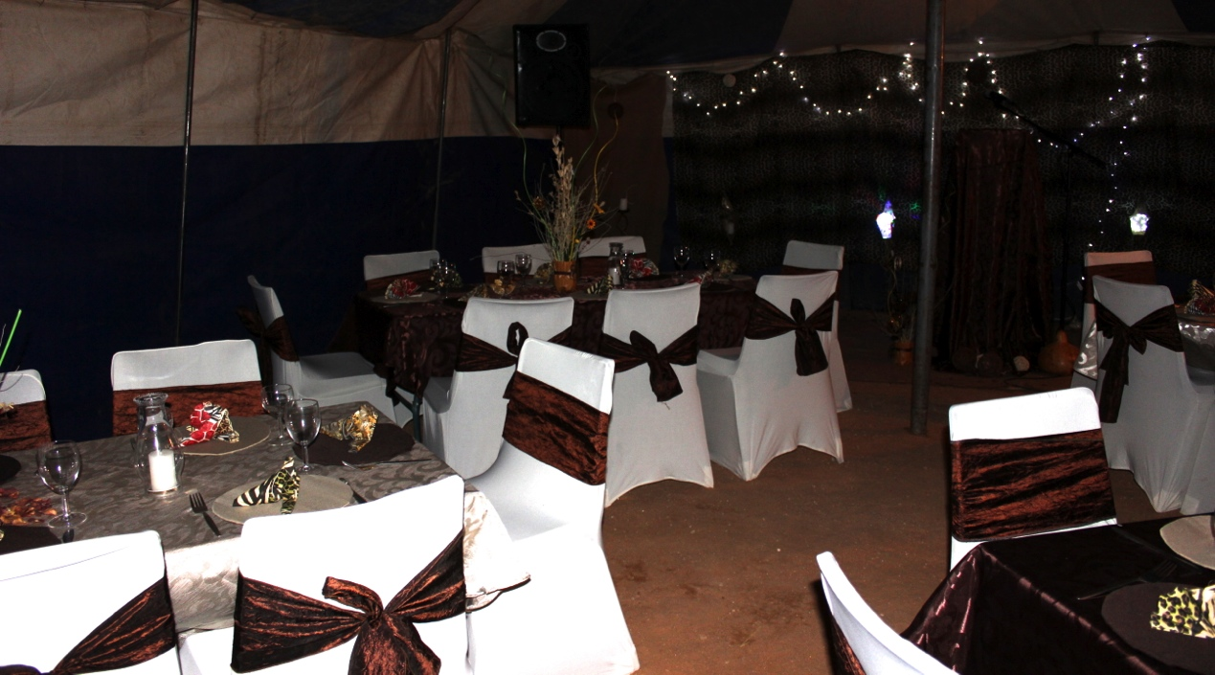

The guests of honour at the dinner were Mr Sebastian Ignatius !Husi !Gobs, the regional councillor for the Kunene region, and Mr Kenneth /Uiseb, the Deputy Director of the Ministry of Environment and Tourism (MET). These two gentlemen delivered the main speeches at the dinner, and personally contributed to the funds raised. The main sponsors of the event were Mr Vitor Azeveto the joint-venture partner for Sorris-Sorris’ /Horoti Lodge, the Kunene regional council, and MET. The other speakers included Daure Daman Traditional Authority councillor Mr Bernard //Garoeb on behalf of the local traditional authority, and other community members and visiting guests who pledged money to support the conservancy.

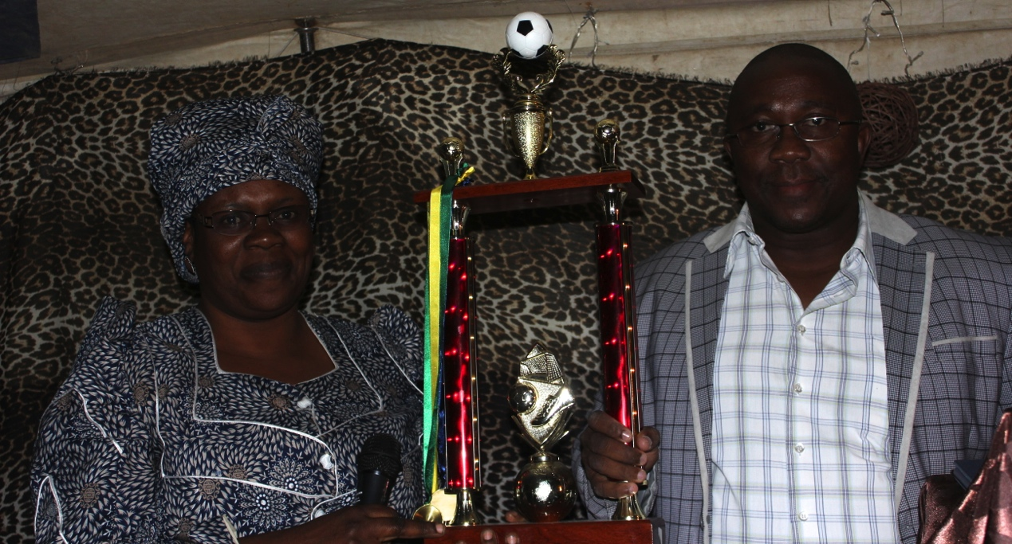
The chairlady of Sorris-Sorris Conservancy, Sylvia !Hoaes with Regional Councillor Mr. !Gobs – holding the trophy for the upcoming Conservancy Cup tournament.
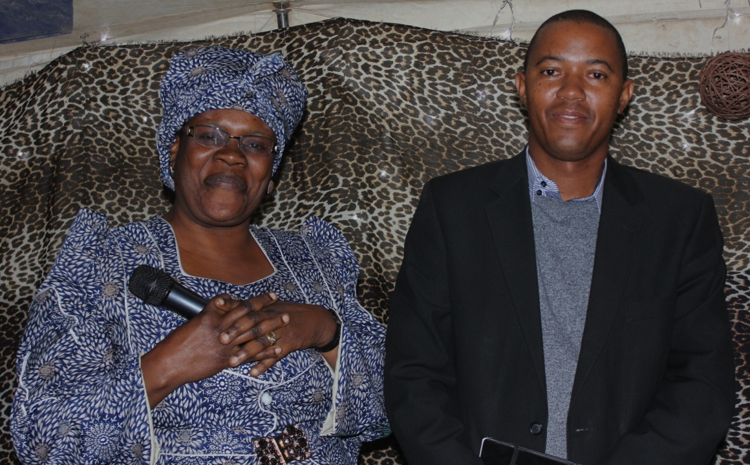
Sylvia !Hoaes with MET Deputy Director Mr /Uiseb

The committee of Sorris-Sorris Conservancy must be commended for their efforts to uplift the conservancy, in spite of their lack of funds. The future is bright for this conservancy, as their community campsite Madisa has re-opened for business, and their new lodge will be operational at the start of 2015. As these tourism ventures start to bring in funds, Sorris-Sorris will be set to become a highly successful conservancy. The current committee has set a high standard for future Sorris-Sorris committees, and has provided a good example for other conservancies. The phenomenal Gala dinner hall was decorated and catering by GiTeGa Catering Cc Company. Entertainment Recreation was provided by Mr Duiker Tsuseb /guri ma /khaeb and his backing Guitarist meaning (standing alone lonely Oryx or Gemsbuck) and Eiseb entertainment Mr Clarence Eiseb known as CJ of National Radio and his companion Dj nelly which was the brilliant memory for conservancy members at its best.sorris Sorris meaning abundance of sun…..see you at Environmental of communal conservancies.

